
Performance Comparison of Virtualized and Traditional Cloud Gaming Infrastructure
A CAPSTONE PROJECT REPORT

A Capstone Project Report submitted in partial fulfilment of the requirements
for the Course of

CSA1519 – Cloud Computing and Big Data Analytics
to the award of the degree of

BACHELOR OF TECHNOLOGY
IN
Artificial Intelligence and Machine Learning
Submitted by
Juhi Surin (192525148)

Under the Supervision
Dr. Govindasamy C

SIMATS ENGINEERING

Saveetha Institute of Medical and Technical Sciences

Chennai – 602105
SEPTEMBER 2026

SIMATS ENGINEERING

Saveetha Institute of Medical and Technical Sciences
Chennai – 602105
BONAFIDE CERTIFICATE
This is to certify that the Capstone Project entitled “Performance Comparison of Virtualized and Traditional Cloud Gaming Infrastructure” has been carried out by Juhi Surin (192525148) as an individual contribution to the team project, with primary responsibility for Module 3 – Performance Data Collection & Big Data Analytics, under the supervision of Dr. Govindasamy C, Professor, Department of CSE, SIMATS Engineering, and is submitted in partial fulfilment of the requirements for the current semester of the B.Tech Artificial Intelligence and Machine Learning programme at SIMATS Engineering, Chennai.

COURSE COORDINATOR  Dr. A. Gnana Soundari,  Professor,  CSE/Machine Learning,  SIMATS Engineering,  SIMATS, Chennai – 602105. | COURSE FACULTY  Dr. Govindasamy C,  Professor,  CSE/Reinforcement Learning,  SIMATS Engineering,  SIMATS, Chennai – 602105.

SIMATS ENGINEERING

Saveetha Institute of Medical and Technical Sciences
Chennai – 602105
DECLARATION

I, Juhi Surin of the Department of B.Tech Artificial Intelligence and Machine Learning , SIMATS Engineering, Saveetha Institute of Medical and Technical Sciences, Chennai, hereby declare that this individual Capstone Project Report entitled “Performance Comparison of Virtualized and Traditional Cloud Gaming Infrastructure” documents my individual contribution to the team project, with primary responsibility for Module 3 – Performance Data Collection & Big Data Analytics. The report includes the overall project context where necessary, while the implementation, testing, analysis and detailed discussion of Module 3 represent my assigned work. The team members for the project are Kavya Jasmine V (192521133),Yenike Manasa Sai (192473023) and Sana Fatima M (192371082). All sources, references, data and other materials used in the project have been appropriately acknowledged. I confirm that the data, results, analysis and findings presented in this report have not been fabricated, falsified or manipulated, and that applicable academic, ethical and professional requirements have been followed.

Place: Chennai
Date: September 2026
Signature of the Student
Juhi Surin(192525148)

INDIVIDUAL CONTRIBUTION STATEMENT

Student Name /  Register No. | Specific Responsibilities | Design & Development Contribution | Testing & Analysis Contribution | Report Contribution | Approx.  Contribution (%)
Juhi Surin  192525148 | Module 3 – Performance Data Collection & Big Data Analytics | Defined metric-collection workflow; structured data pipeline; analytics integration; comparison design | Metric verification; repeated-test methodology; comparative analysis; interpretation of performance variation | Chapters 1–5 sections related to Module 3; tables, figures, testing, analysis, appendices | 25%
Kavya Jasmine V  192521133 | Team project implementation | Team implementation contribution | Team testing/analysis contribution | Team report contribution | 25%
Sana Fatima M  192371082 | Team project implementation | Team implementation contribution | Team testing/analysis contribution | Team report contribution | 25%
Yenike Manasa Sai  192473023 | Team project implementation | Team implementation contribution | Team testing/analysis contribution | Team report contribution | 25%
TOTAL |  |  |  |  | 100%

Note: The project presentation identifies four team members but does not provide a formal hour-based contribution record. The 25% values are therefore used as an equal module-based allocation for the mandatory institutional table and should be replaced if the team has an officially approved contribution record.

ABSTRACT
Cloud gaming transfers game execution and rendering from the client device to remote computing infrastructure and streams the interactive output back through a network. This project addresses the engineering problem of determining how virtualization influences cloud-gaming performance when compared with traditional direct execution on server infrastructure. The significance of the problem arises from the interaction of gaming performance, resource utilization, virtualization overhead, and network behaviour: a deployment that improves one parameter may impose a cost on another. The proposed solution establishes comparable traditional and virtualized gaming environments, uses the same game and workload, repeatedly observes FPS, latency, CPU utilization, memory utilization, GPU utilization and bandwidth, stores observations in structured datasets, applies statistical/comparative analytics, and communicates the results through an interactive dashboard. Module 3 forms the measurement and analytics core of this workflow. The supplied project presentation reports successful implementation of both environments, collection of performance metrics, structured data handling, statistical analysis, visualization, and identification of strengths and limitations. The implementation evidence further shows a React/Vite frontend, Recharts visualization support, a FastAPI analytics backend, a Vite proxy for API requests, and a launch script that starts the backend and dashboard. Because the supplied project package does not contain the complete raw numerical experiment dataset, this report does not fabricate numerical FPS, latency, or utilization values; instead, it records the verified analytical methodology and the evidence-supported results. The principal conclusion is that infrastructure selection for cloud gaming should be treated as a measured, multi-metric engineering decision, with virtualization evaluated for its performance impact as well as its isolation and resource-management benefits.
Keywords: Cloud Gaming; Virtualization; Performance Analytics; Latency; Resource Utilization; Big Data

TABLE OF CONTENTS
Sl. No. | Title | Page No.
1 | CERTIFICATE FROM THE SUPERVISOR | i
2 | DECLARATION BY THE CANDIDATE | ii
3 | INDIVIDUAL CONTRIBUTION STATEMENT | iii
4 | ABSTRACT | V
5 | LIST OF FIGURES | Vii
6 | LIST OF TABLES | Vii
7 | LIST OF ABBREVIATIONS | Ix
8 | CHAPTER 1: INTRODUCTION AND ENGINEERING PROBLEM | 1
9 | CHAPTER 2: LITERATURE REVIEW AND EXISTING SOLUTIONS | 5
10 | CHAPTER 3: ENGINEERING DESIGN & TRADE-OFFS, SUSTAINABILITY, ETHICS, SAFETY, RISK & SECURITY | 9
11 | CHAPTER 4: IMPLEMENTATION, TESTING & RESULTS, PROJECT MANAGEMENT | 20
12 | CHAPTER 5: CONCLUSION, FUTURE WORK AND REFLECTION | 35
13 | REFERENCES | 38
14 | APPENDICES | 40
15 | CAPSTONE PROJECT OUTCOME MAPPING SHEET | 44

LIST OF FIGURES
Figure No. | Figure Name | Page No.
Fig. 1 | Monochrome system architecture of the proposed cloud-gaming benchmark | 4
Fig. 2 | Traditional and virtualized environment comparison workflow | 14
Fig. 3 | Module 3 performance-data collection and analytics flow | 15
Fig. 4 | Performance metric classification and analysis path | 19
Fig. 5 | Project milestone / Gantt timeline | 22
Fig. 6 | Risk likelihood–severity matrix | 29
Fig. 7 | Supplied project implementation evidence – cloud-gaming comparison | 32

LIST OF TABLES
Table No. | Table Name | Page No.
Table 1 | Stakeholder / User Requirements | 9
Table 2 | Functional & Non-Functional Requirements | 10
Table 3 | Applicable Constraints | 11
Table 4 | Applicable Standards | 11
Table 5 | Design Specifications | 12
Table 6 | Alternative-Solution Evaluation Matrix | 13
Table 7 | Design Trade-off Analysis | 16
Table 8 | Sustainability, Ethics, Health & Safety, Security | 17
Table 9 | Risk Register | 18
Table 10 | Resources and Purposeful Tools | 20
Table 11 | Test Plan & Verification | 23
Table 12 | Evidence-Based Results | 25
Table 13 | Data Collection Template | 26
Table 14 | Objective Achievement | 30
Table 15 | Project Milestones | 32
Table 16 | Roles & Contributions | 33
Table 17 | Budget | 34

LIST OF ABBREVIATIONS / SYMBOLS
Symbol | Description | Unit
AI | Artificial Intelligence | —
API | Application Programming Interface | —
CPU | Central Processing Unit | %
GPU | Graphics Processing Unit | %
FPS | Frames Per Second | frames/s
RAM | Random Access Memory | GB / %
VM | Virtual Machine | —
CSV | Comma-Separated Values | —
Vite | Frontend development/build tool | —
React | JavaScript library for user interfaces | —
FastAPI | Python web framework for APIs | —
JSON | JavaScript Object Notation | —
CCBDA | Cloud Computing and Big Data Analytics | —
ms | Millisecond | ms
Mbps | Megabits per second | Mbps

CHAPTER 1

INTRODUCTION AND ENGINEERING PROBLEM

1.1 Background
Cloud gaming is a distributed computing model in which the game application executes on remote computing infrastructure and the rendered output is delivered to a client through a network. The user interacts with the remote application as if it were running locally, but the computational workload, rendering workload and a substantial part of the system state are handled by the remote environment.
In the project under study, two infrastructure approaches are compared. The traditional environment executes the game directly on the available host/server infrastructure, whereas the virtualized environment executes the same game inside a virtualized container or environment. The supplied project presentation explicitly states that both environments are configured with comparable computing and network resources and that the same game and workload are used to ensure a fair comparison.
The engineering significance is that cloud-gaming performance is not determined by one variable. FPS, latency, CPU, memory, GPU and bandwidth interact with the infrastructure design. Virtualization can provide isolation and resource-management flexibility, but the additional abstraction layer may influence resource consumption and timing. The project therefore uses performance data and analytics rather than relying only on theoretical claims.

1.2 Need for the Project
The problem needs to be addressed because an infrastructure decision affects the quality, efficiency and scalability of a cloud-gaming service. A deployment that is inexpensive or highly isolated may not automatically provide the best interactive performance. Conversely, a direct host deployment may offer lower abstraction overhead but less flexibility in sharing and isolating resources.
The principal stakeholders are cloud/service operators, infrastructure engineers, gaming companies, end users, researchers and project evaluators. Cloud providers need evidence for resource allocation; gaming companies need a basis for selecting deployment environments; users need responsive gameplay; and researchers need repeatable measurements for studying virtualization and cloud resource management.
The existing limitation addressed by this project is the difficulty of making a multi-dimensional comparison from manual observation. The project responds by defining a common workload, collecting a common metric set, storing structured observations, applying analytics and presenting the comparison through a dashboard.

1.3 Problem Statement
To design and evaluate a reproducible performance-data collection and big-data analytics workflow for comparing virtualized and traditional cloud-gaming infrastructure under comparable workloads, while accounting for interacting factors including frame delivery, latency, CPU/GPU/memory utilization, bandwidth, virtualization overhead, network variability, resource contention, data integrity, security and practical resource constraints.
The engineering problem contains multiple interacting factors because gaming responsiveness depends simultaneously on computation and communication. It is technically complex because the same workload passes through different execution layers. It has conflicting requirements because low overhead, high isolation, efficient resource sharing, low latency and low cost cannot always be maximized simultaneously. It is constrained by available hardware, network conditions, software configuration and the availability of complete raw experimental records.

1.4 Project Aim
To establish a practical, evidence-oriented framework for comparing virtualized and traditional cloud-gaming infrastructure through performance data collection, structured data processing, big-data analytics and comparative visualization.

1.5 Project Objectives
- To implement a cloud-gaming environment for remote game execution and streaming.
- To create traditional and virtualized gaming environments under comparable conditions.
- To collect performance metrics including FPS, latency, CPU utilization, memory utilization, GPU utilization and bandwidth.
- To store collected observations in structured datasets for downstream processing.
- To apply data-cleaning, descriptive/statistical and comparative analytics to identify performance patterns and variations.
- To visualize comparative performance through an interactive analytics dashboard.
- To evaluate strengths, limitations, bottlenecks and infrastructure trade-offs and identify the more efficient deployment for the measured workload.

1.6 Scope
Included in scope: cloud/server infrastructure setup; remote game execution and streaming; traditional direct execution; virtualized/containerized execution; comparable resource configuration; repeated workload execution; collection of FPS, latency, CPU, memory, GPU and bandwidth; structured data storage; analytics; visualization; comparison; engineering interpretation; risk/security considerations; and technical documentation.
Excluded from scope: a production-scale commercial deployment, a statistically complete cross-region cloud-provider benchmark, claims about a universal winner across all games, and numerical values that cannot be traced to the original raw experimental dataset supplied with the project files.
Assumptions: the same game and workload are used for both environments; the computing and network conditions are kept comparable; metric definitions remain consistent between runs; and the analytics process receives valid structured observations. Boundary conditions include network variability, resource contention, virtualization overhead, available compute/GPU resources, and the completeness of recorded run metadata.

1.7 Expected Engineering Outcome
The intended engineering outcome is an infrastructure-and-analytics solution consisting of a cloud/server gaming environment, traditional and virtualized execution paths, a performance-data collection process, structured performance datasets, a big-data analytics layer and an interactive comparative dashboard. The deliverable is therefore best classified as an integrated engineering infrastructure solution and software/data-analysis prototype.

1.8 Project Modules and System Context
Module | Project Activity | Relationship to Module 3
Module 1 | Cloud Gaming Infrastructure Setup | Provides the server, resources, streaming path and client connectivity from which measurements originate.
Module 2 | Virtualized & Traditional Environment Implementation | Creates the two comparable execution conditions that Module 3 measures.
Module 3 | Performance Data Collection & Big Data Analytics | Own module: collects, structures, analyses and interprets performance observations.
Module 4 | Comparative Analytics Dashboard | Consumes analysed results and communicates comparisons using graphs and visualizations.

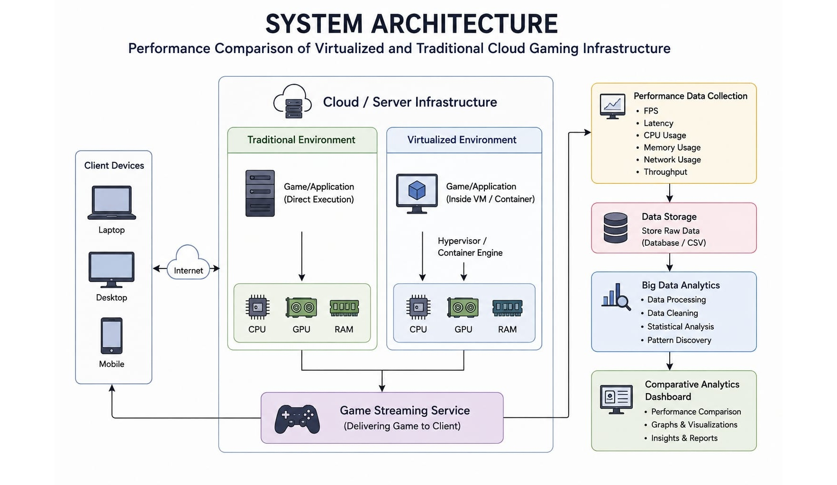
Figure 1. Colour system architecture of the proposed cloud-gaming benchmark.

CHAPTER 2

LITERATURE REVIEW AND EXISTING SOLUTIONS

2.1 Review Method
The review used the references supplied in the project presentation and grouped them according to the engineering themes they address: containerized cloud gaming, real-time network measurement, latency, scalable cloud-gaming architecture, virtualization, cloud infrastructure and edge computing. The review then mapped those themes to the project's measurable parameters and design decisions. Commercial/industry context is represented by the GeForce NOW measurement study included in the supplied references; this report does not claim to have benchmarked that commercial service.
No patent was identified as a required dependency for the supplied project implementation. The work is therefore treated as an engineering benchmarking and analytics study rather than a patent-based implementation.

2.2.5 Patents
The principal technologies and methods are cloud/server computing, virtualization or containerization, remote game streaming, structured performance-data collection and comparative analytics. The benchmark method uses a common workload, comparable resources and repeated observations.

2.2.4 Technologies and Methods
Commercial cloud-gaming services demonstrate the practical use of remote execution and streaming. The cited NVIDIA GeForce NOW measurement study is directly relevant because it treats real-time network behaviour as an important part of cloud-gaming performance.

2.2.3 Commercial Solutions
Existing cloud-gaming systems execute games remotely and stream rendered output to clients. The proposed benchmark retains this overall service model while introducing a controlled comparison between direct host execution and virtualized execution.

2.2.2 Existing Systems
The project presentation cites recent work on containerized cloud gaming, real-time network measurement, latency challenges, scalable cloud gaming and virtualization. These studies establish the technical basis for evaluating compute, network and infrastructure effects in cloud gaming.

2.2.1 Research Papers

2.2 Review of Existing Work
Reference / Approach | Critical Review | Project Relevance
Gegout et al. (2025) – Efficient Containerized Cloud Gaming Platform | Focuses on efficient containerized cloud-gaming infrastructure. It directly supports consideration of containerization/virtualization as a performance and resource-management variable. | Motivates the virtualized-vs-traditional infrastructure comparison.
Lyu et al. (2024) – Network Anatomy and Real-Time Measurement of NVIDIA GeForce NOW | Emphasizes real-time network behaviour in cloud gaming. This highlights the need to observe latency and bandwidth rather than judging only rendering performance. | Supports network-performance metrics in Module 3.
Tanveer et al. (2024) – Latency Challenges in Cloud Gaming | Treats latency as a central challenge to interactive cloud gaming and reviews approaches to reduce it. | Supports latency as a high-priority performance variable.
De Oliveira et al. (2023) – Scalable Cloud Gaming Systems | Investigates scalable architectures and separation of game-physics concerns, showing that architecture influences scalability and performance. | Supports a system-level rather than single-component evaluation.
Baloni et al. (2023) – Evolution of Virtualization and Cloud Computing | Provides broader infrastructure context for virtualization and cloud computing evolution. | Supports the rationale for studying resource abstraction and utilization.
Lambropoulos et al. (2026) – Virtualization, Cloud and Edge Infrastructure | Connects virtualization and cloud infrastructures with edge-computing applications and modern infrastructure decisions. | Supports future extension toward edge/multi-platform testing.

2.3 Comparative Analysis
Existing Work / Approach | Advantages | Limitations | Relevance to Proposed Work
Containerized cloud gaming | Isolation, repeatable deployment, resource sharing | Additional abstraction may introduce overhead; configuration complexity | Provides the virtualized comparison condition.
Real-time network measurement | Captures dynamic network effects and responsiveness | Network-centric view may not explain compute bottlenecks | Adds latency/bandwidth dimensions to multi-metric analysis.
Latency-focused methods | Directly addresses interactive responsiveness | Latency alone cannot explain GPU/CPU/memory behaviour | Project combines latency with resource metrics.
Scalable cloud-gaming architectures | Addresses system decomposition and scalability | May require infrastructure beyond a student-scale benchmark | Supports system-level thinking and future scaling.
General virtualization/cloud infrastructure | Explains abstraction and resource management | Not necessarily specific to gaming workloads | Provides infrastructure design context.

2.4 Research / Engineering Gap
The literature establishes that cloud gaming is sensitive to networking, latency, resource management, virtualization and scalability. The unresolved engineering requirement addressed by this project is the practical integration of these dimensions into a single repeatable comparison workflow. Instead of examining virtualization, networking or analytics in isolation, the project links two execution environments to a common measurement set, structured data and comparative visualization.

2.5 Proposed Contribution
The proposed contribution is an end-to-end performance benchmarking and analytics workflow. Its contribution is methodological and implementation-oriented: it creates a common measurement basis for traditional and virtualized environments, organizes the observations as structured data, applies statistical/comparative reasoning, and presents the resulting differences through an interactive dashboard. Module 3 is the central bridge between infrastructure execution and evidence-based engineering judgement.

2.6 Advantages of the Proposed Approach
- It provides a practical comparison between virtualized and traditional infrastructure.
- It uses real performance metrics rather than relying only on theoretical analysis.
- Structured performance data enables repeatable analysis across multiple runs and metrics.
- Big-data analytics supports efficient processing of larger performance datasets as the experiment grows.
- The dashboard provides an accessible visual interpretation of experimental evidence.
- The approach helps identify resource utilization patterns and potential performance bottlenecks.

2.7 Applications
- Evaluation of cloud-gaming service performance.
- Optimization of computing and GPU resource allocation by cloud providers.
- Selection of suitable deployment environments by gaming companies.
- Research on virtualization and cloud resource management.
- Extension to other resource-intensive cloud applications where remote execution and resource sharing are important.

CHAPTER 3

ENGINEERING DESIGN & TRADE-OFFS, SUSTAINABILITY, ETHICS, SAFETY, RISK & SECURITY

3.1 Requirements

3.1.1 Stakeholder / User Requirements
Stakeholder | Requirement
Cloud/service provider | Measure resource consumption and performance so compute/GPU allocation can be optimized.
Gaming service operator | Provide stable remote game execution and streaming with acceptable responsiveness.
End user | Receive responsive gameplay with consistent frame delivery and acceptable latency.
Infrastructure engineer | Maintain comparable configurations and isolate the effect of virtualization where possible.
Data analyst | Receive structured, complete and consistently defined performance observations.
Project evaluator | Verify the engineering method, evidence, limitations and objective achievement.

3.1.2 Functional & Non-Functional Requirements
Requirement | Type | Measurable Target
Remote game execution | Functional | Game runs on server/cloud environment and is accessible through streaming path.
Two execution conditions | Functional | Traditional and virtualized environments use the same game/workload.
Comparable resources | Functional | Computing and network conditions are kept comparable between environments.
Performance collection | Functional | FPS, latency, CPU, memory, GPU and bandwidth are recorded.
Structured data | Functional | Observations are stored with consistent fields/units and run identifiers.
Analytics | Functional | Cleaning, descriptive statistics and comparative analysis can be performed.
Visualization | Functional | Dashboard presents comparative metrics and trends.
Repeatability | Non-Functional | The same test procedure can be repeated under controlled conditions.
Data integrity | Non-Functional | No fabricated/altered measurements; missing data are identified.
Security | Non-Functional | Backend/API and datasets are accessible only to intended project users/components.
Usability | Non-Functional | Dashboard allows parameter-based comparison and understandable visual interpretation.

3.2 Constraints & Applicable Standards

3.2.1 Applicable Constraints
Constraint Category | Actual Constraint | Engineering Effect
Technical | Different execution layers and possible virtualization overhead | Requires controlled comparison and multi-metric measurement.
Network | Latency/bandwidth vary with network conditions | Requires repeated runs and consistent test conditions.
Resource | CPU/GPU/memory availability and contention can vary | Requires resource observation and background-load control.
Economic | Student-scale project resources are limited | Favors software/open-source tooling and reuse of existing resources.
Data | Complete raw numerical dataset is not included in supplied package | Prevents unsupported numerical claims in this report.
Security | Backend/API can expose project services if deployed carelessly | Requires controlled/local access and protected deployment.
Ethical | Performance evidence must be accurate and traceable | Requires explicit evidence boundaries and no fabricated values.

3.2.2 Applicable Standards / Codes
Standard / Code | Requirement / Focus | How Applied in This Project
IEEE 29148 | Requirements engineering: clear, consistent, verifiable requirements. | Functional and non-functional requirements are expressed with measurable targets.
IEEE 1012 | Verification and validation planning. | Test methods and acceptance criteria are defined before result interpretation.
ISO/IEC 25010 | Software quality characteristics including performance efficiency, reliability and security. | Used as a quality lens for performance, reliability, usability and security considerations.
IEEE 830 / legacy requirements guidance | Structured software requirements documentation. | Used as supporting documentation guidance where appropriate.

These standards are used as engineering guidance in the report; the project does not claim formal certification or compliance assessment against them.

3.3 Design Specifications
Parameter | Target / Requirement | Unit | Priority
FPS | Consistent frame-rate measurement for both environments | frames/s | High
Latency | Consistent end-to-end/network latency definition | ms | High
CPU utilization | Record utilization under the same workload | % | High
Memory utilization | Record memory consumption/utilization | GB / % | Medium
GPU utilization | Record graphics-resource utilization | % | High
Bandwidth | Record network usage/throughput | Mbps | High
Run identity | Every observation traceable to environment and run | ID | High
Repeatability | Repeated executions under comparable conditions | runs | High
Dashboard comparison | Metrics selectable and visually comparable | qualitative | Medium

3.4 Alternative Solutions & Evaluation
Alternative 1 – Direct host execution with lightweight manual analysis: the game is executed directly on the host and observations are compared using a simple spreadsheet or static report. It has low setup overhead but limited automation and repeatability for multi-metric analytics.
Alternative 2 – Virtualized/containerized execution plus structured API-driven analytics: the gaming workload is isolated through a virtualization layer and performance observations are processed through a backend and dashboard. It adds infrastructure complexity but provides stronger separation and a reusable analytical workflow.
Alternative 3 – Manual spreadsheet-only benchmarking: measurements are entered and compared manually. It is simple and inexpensive but becomes error-prone and less interactive as the number of runs and metrics increases.
Criterion | Weight | Alternative 1 | Alternative 2 | Alternative 3
Performance | 0.30 | High | High | Medium
Cost | 0.15 | High | Medium | High
Safety / Isolation | 0.15 | Medium | High | Low
Sustainability | 0.15 | High | Medium | High
Reliability / Repeatability | 0.25 | Medium | High | Low

Selection: Alternative 2 is used as the project-level design because the project objective is specifically to compare virtualized and traditional execution while processing multiple metrics through an analytics pipeline. The evaluation therefore favours repeatability, isolation and integrated analysis without requiring a production-scale infrastructure.

3.5 Selected Design & Detailed Design
The selected design uses the cloud/server infrastructure as the common execution platform, with two comparable paths: traditional direct execution and virtualized execution through a VM/container or equivalent virtualization environment. Both paths feed the same game-streaming service and measurement process. Performance observations move into structured storage, then into the analytics layer, and finally into the comparative dashboard.

Figure 2. Colour architecture showing client devices, cloud/server infrastructure, traditional and virtualized execution, streaming, data collection, storage, analytics and dashboard.

3.5.1 Traditional Execution Path
The traditional path executes the game/application directly on the host/server operating environment. Its principal advantage for this comparison is the absence of an additional virtualization layer between the game workload and the host resources. Its measured behaviour forms the baseline against which the virtualized path is compared.

3.5.2 Virtualized Execution Path
The virtualized path executes the same game/application inside a virtualized environment such as a VM or container. A hypervisor or container engine provides the abstraction boundary. The comparison is intended to reveal how this layer affects resource utilization and interactive performance under an otherwise comparable workload.

3.5.3 Module 3 Data Path
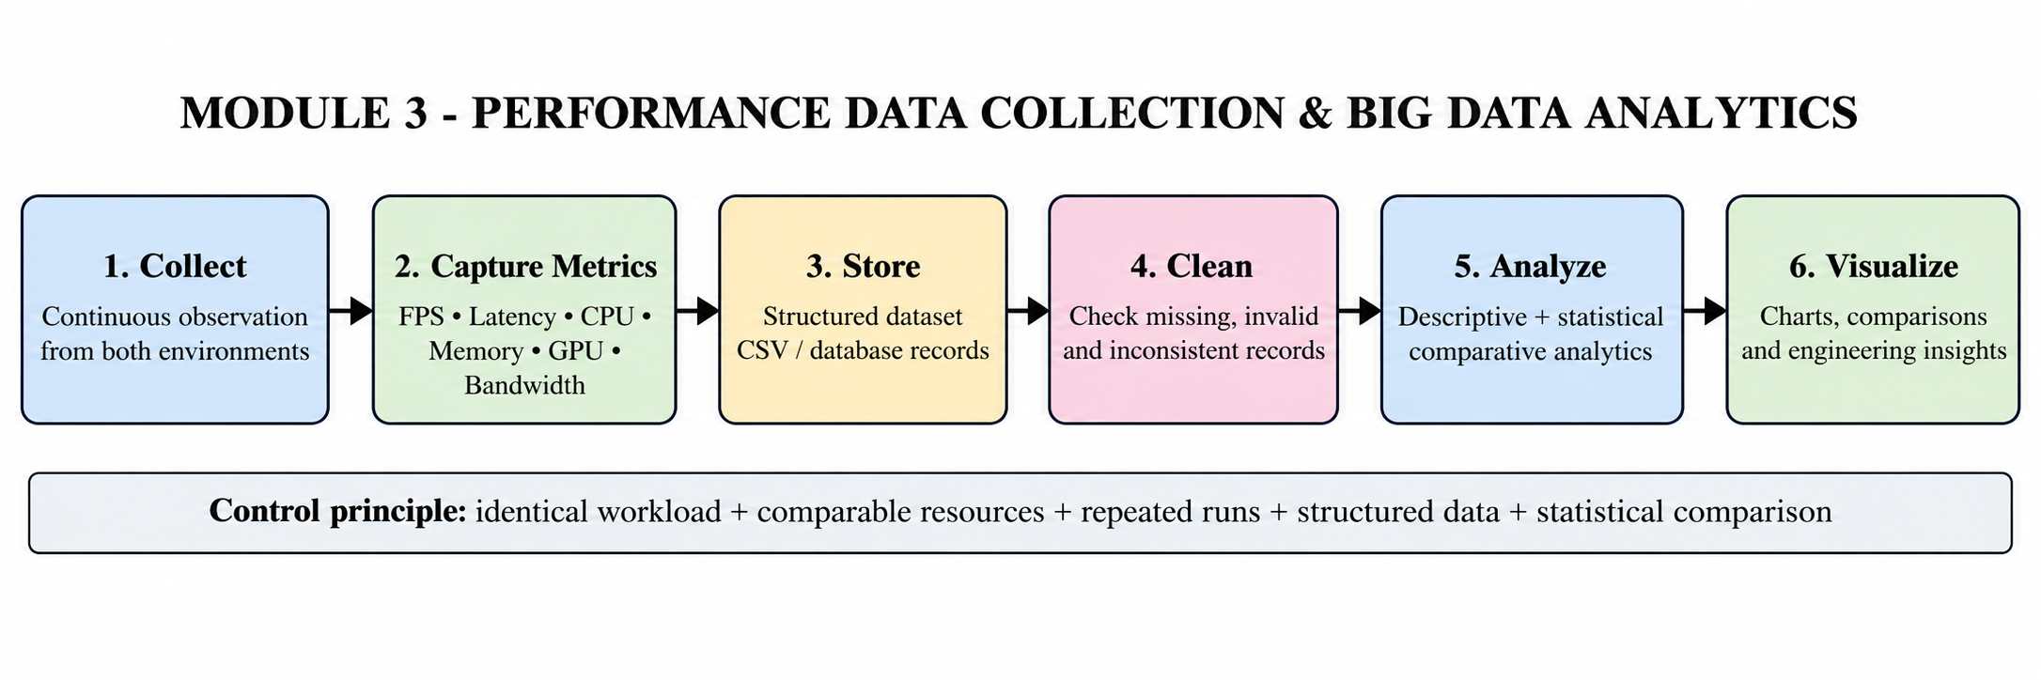
Figure 3. Colour Module 3 performance-data collection, validation, storage, analytics and decision flow.

3.5.4 Essential Engineering Calculations
For repeated observations x₁, x₂, …, xₙ, the arithmetic mean is x̄ = (1/n)Σxᵢ. Sample standard deviation is s = √[Σ(xᵢ−x̄)²/(n−1)]. Percentage difference between virtualized and traditional measurements is Δ% = ((xᵥ−xₜ)/xₜ)×100. For FPS, a positive difference generally indicates higher frame delivery; for latency, a negative difference generally indicates improvement. Utilization metrics require contextual interpretation because lower utilization is not automatically better if it indicates under-utilization or a different workload state.

3.5.5 Systems Approach
The client depends on the streaming service to deliver the remotely executed game. The streaming service depends on either the traditional or virtualized execution environment for rendered output and on the network for delivery. The performance-data layer depends on both execution paths to provide comparable observations. The analytics and dashboard layers depend on valid structured measurements; therefore, data quality directly influences the validity of the final engineering decision.

3.6 Trade-off Analysis
Design Decision | Alternative Considered | Benefit | Disadvantage | Final Decision & Justification
Use two comparable execution paths | Traditional-only benchmark | Direct baseline | Cannot isolate virtualization effect | Use traditional + virtualized paths because comparison is the project objective.
Structured analytics pipeline | Manual spreadsheet-only analysis | Repeatable processing and easier scaling | Requires backend/data-model effort | Use structured pipeline because multiple metrics and repeated runs are expected.
Interactive dashboard | Static tables only | Fast visual comparison | Frontend development effort | Use dashboard because the project explicitly requires comparative visualization.
Repeated runs | Single-run measurement | Faster experiment | Poor robustness to variability | Use repeated runs because network/resource conditions vary.
Evidence boundary | Fill missing numbers from assumptions | Looks complete | Would create unsupported claims | Retain explicit missing-data limitation for academic integrity.

3.7 Sustainability, Ethics, Safety, Risk & Security
Domain | Consideration | Evidence Evaluated | Impact on Final Decision
Sustainability | Avoid unnecessary compute and uncontrolled repeated runs. | Resource metrics, reuse of structured data, limited project resources. | Controlled repeated runs and reusable datasets are preferred.
Ethics | Maintain traceability and avoid fabricated measurements. | Supplied PPT, implementation files and availability of raw-data evidence. | Unsupported numerical values are excluded from the report.
Health & Safety | Software/cloud project has no fabrication hazard identified. | Project materials; no hazardous physical process supplied. | Safety emphasis is responsible workstation, electrical and network use.
Security | Protect backend/API, datasets and infrastructure access. | Local API target and launcher; project architecture. | Use controlled/local access and protected deployment if moved to a network.
Professional responsibility | Document limitations and assumptions. | Institutional report guidance and project evidence. | Conclusions are limited to evidence-supported claims.

Risk Register
Risk | Likelihood | Severity | Risk Level | Mitigation | Residual Risk
Network variability | High | Medium | High | Repeat runs; record conditions; compare like-for-like | Medium
Resource contention | Medium | High | High | Control background workloads; observe CPU/GPU/memory | Medium
Measurement inconsistency | Medium | High | High | Fixed metric definitions, units and run identifiers | Low–Medium
Virtualization overhead | Medium | Medium | Medium | Compare same workload under comparable resources | Low–Medium
Data loss/corruption | Low | High | Medium | Structured storage, backup and versioned files | Low
Unauthorized API access | Low | High | Medium | Local/protected backend; restrict network exposure | Low
Incomplete raw dataset | High | Medium | High | State evidence limitation; do not invent values | Low
Incorrect interpretation | Medium | High | High | Use multi-metric analysis and contextual judgement | Medium

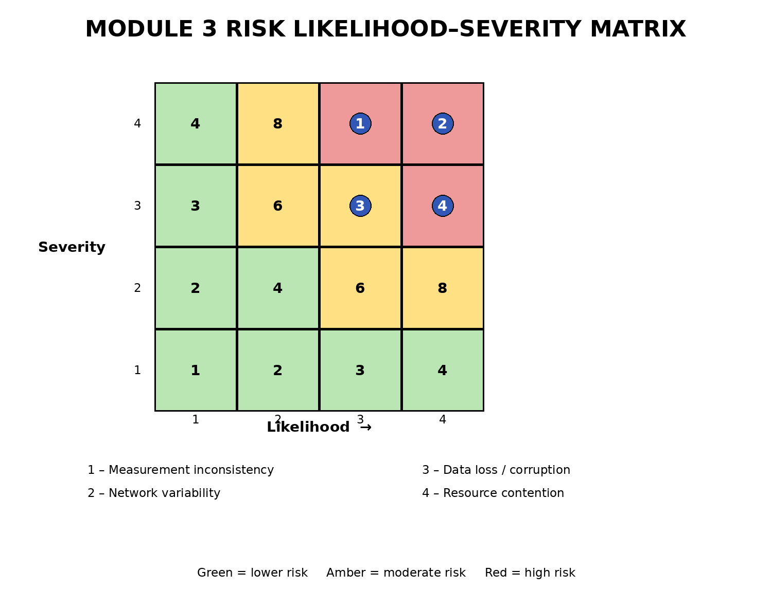
Figure 4. Colour risk likelihood–severity matrix used for the Module 3 risk assessment.

CHAPTER 4

IMPLEMENTATION, TESTING & RESULTS, PROJECT MANAGEMENT

4.1 Development Approach & Resources
The implementation follows a staged engineering workflow: first establish the cloud/server gaming environment; then implement comparable traditional and virtualized execution; next collect and structure performance observations; then apply analytics; and finally expose the comparison through an interactive dashboard. Module 3 is implemented as the measurement-to-analysis stage and depends on the environment established in Modules 1 and 2 and feeds the visualization delivered in Module 4.
Resource / Component | Purpose | Stage Used
Cloud / server infrastructure | Remote game execution and streaming | Module 1
Traditional environment | Baseline execution condition | Module 2
Virtualized environment | Comparison execution condition | Module 2
FPS / latency / CPU / memory / GPU / bandwidth | Performance evidence | Module 3
Structured dataset | Persistent analytical input | Module 3
Python FastAPI | Analytics/API backend | Module 3 / Dashboard integration
React 18.2.0 | Interactive frontend | Module 4
Vite 5.1.6 | Frontend development/build server | Module 4
Recharts 2.12.2 | Charts and data visualization | Module 4
Lucide React 0.344.0 | Interface icons | Module 4

4.2 Hardware / Software / Fabrication Implementation & Modern Tools Used

4.2.1 Hardware / Infrastructure
The project uses client devices and cloud/server computing infrastructure as represented in the supplied architecture. The exact processor, GPU model, RAM capacity and network equipment specifications are not included in the supplied text/code package, so this report records the functional resource classes rather than inventing hardware specifications.
Infrastructure Element | Purpose | Evidence Status
Client laptop/desktop/mobile class device | Receives the game stream and provides user interaction | Shown in supplied architecture
Cloud/server host | Executes the game workload and provides compute resources | Specified in project presentation
CPU | General-purpose game/application computation | Metric explicitly collected
GPU | Rendering/graphics workload | Metric explicitly collected
RAM | Memory allocation for execution | Metric explicitly collected
Network link | Carries interactive stream and traffic | Latency/bandwidth explicitly collected

4.2.2 Software Implementation
The supplied package manifest identifies React, React DOM, Recharts and Lucide React as application dependencies and Vite with the React plugin as development dependencies. The launcher starts the Python FastAPI analytics backend on 127.0.0.1:8000 and the React/Vite dashboard through npm run dev, then opens the dashboard at localhost:3000. The Vite configuration proxies /api requests to the FastAPI backend.
Tool / Software | Purposeful Use | Stage Used
Python FastAPI | Analytics service/API | Module 3
React 18.2.0 | Interactive dashboard UI | Module 4
React DOM 18.2.0 | Browser rendering for React | Module 4
Recharts 2.12.2 | Charts for comparative metrics | Module 4
Lucide React 0.344.0 | Dashboard interface icons | Module 4
Vite 5.1.6 | Frontend dev/build server | Module 4
@vitejs/plugin-react 4.2.1 | React integration with Vite | Module 4
npm / Node.js | Frontend package management and execution | Module 4
Windows batch script | One-command project startup | Implementation support

4.2.3 Fabrication
No physical fabrication process is evidenced in the supplied project materials. The project is a software, cloud-infrastructure and data-analytics implementation; therefore, fabrication is not applicable.
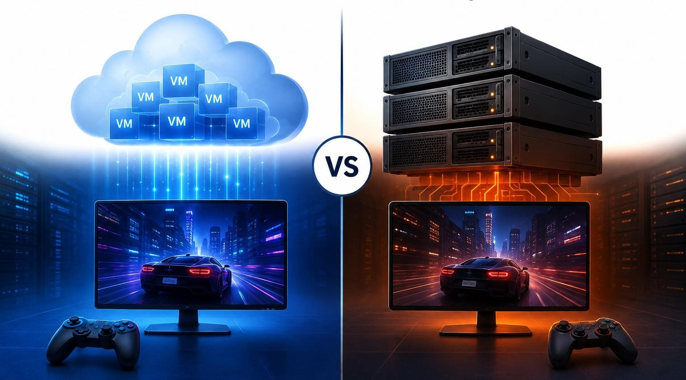
Figure 5. Supplied project visual comparing virtualized and traditional cloud-gaming infrastructure.

4.3 Test Plan & Verification
The test plan is defined before result interpretation. The central verification principle is controlled comparison: use the same game/workload, maintain comparable computing/network resources, repeat the experiment, use consistent metric definitions, and retain run identifiers. A test is considered successful only when the required functionality is demonstrated and the evidence is traceable.
Specification | Test Method | Required Value | Achieved Value / Evidence | Status
Cloud gaming execution | Run the game on the server and deliver through streaming path. | Remote execution and streaming available | Project presentation states cloud/server setup, remote streaming and client connection. | PASS
Traditional environment | Execute game directly on host. | Traditional path available | Project presentation describes direct host execution. | PASS
Virtualized environment | Execute same game inside VM/container/virtualized environment. | Virtualized path available | Project presentation describes virtualized execution. | PASS
Comparable workload | Use same game/workload and comparable resources. | Same workload/conditions | Project presentation explicitly states same game/workload and comparable resources. | PASS
Performance collection | Record FPS, latency, CPU, memory, GPU and bandwidth. | All listed metrics available | Project presentation explicitly states these metrics are recorded. | PASS
Structured data | Store observations for processing. | Structured dataset | Project presentation states collected data are stored in structured datasets. | PASS
Analytics | Process and statistically compare observations. | Patterns/differences identifiable | Project presentation states analytics and statistical analysis are performed. | PASS
Visualization | Display comparison using graphs/charts. | Interactive comparative view | Project presentation states dashboard visualizes metrics; implementation includes Recharts. | PASS
Raw numerical reproducibility | Repeat analysis from complete raw dataset. | Raw values + metadata supplied | Complete raw numerical experiment dataset is not present in supplied package. | NOT VERIFIABLE

4.4 Results
The supplied project presentation reports that both virtualized and traditional cloud-gaming environments were successfully implemented, performance metrics were successfully collected, measurable differences were obtained, analytics and visualizations represented the comparison, and the strengths and limitations of each infrastructure were identified. These statements support the functional completion of the benchmark and analytics workflow.
Result Area | Evidence-Supported Result | Engineering Meaning
Infrastructure | Both virtualized and traditional environments implemented. | A controlled comparison condition exists.
Measurement | FPS, latency, CPU, memory, GPU and bandwidth collected. | Gaming, compute and network behaviour can be evaluated together.
Data preparation | Measurements stored in structured datasets. | Observations can be processed consistently.
Analytics | Performance patterns and variations statistically analysed. | Infrastructure differences can be examined rather than guessed.
Visualization | Comparative dashboard displays metrics and graphs. | Results are accessible for engineering decision-making.
Overall conclusion | Strengths and limitations of each infrastructure identified. | Selection should consider multiple criteria.

4.4.1 Raw Data Collection Template
Run ID | Environment | FPS | Latency (ms) | CPU (%) | Memory (%) / GB | GPU (%) | Bandwidth (Mbps) | Notes
R01 | Traditional | — | — | — | — | — | — | Raw value not supplied
R01 | Virtualized | — | — | — | — | — | — | Raw value not supplied
R02 | Traditional | — | — | — | — | — | — | Raw value not supplied
R02 | Virtualized | — | — | — | — | — | — | Raw value not supplied
R03 | Traditional | — | — | — | — | — | — | Raw value not supplied
R03 | Virtualized | — | — | — | — | — | — | Raw value not supplied

Important: the dashes are deliberate placeholders, not measured values. The original project presentation confirms that measurements were collected, but the numerical dataset was not included in the supplied files used to prepare this report.

4.4.2 Result Visualization Plan
Metric | Recommended Visualization | Purpose
FPS | Grouped bar chart + run-wise line plot | Compare frame delivery and consistency.
Latency | Grouped bar chart + distribution plot | Compare responsiveness and variation.
CPU utilization | Grouped bar chart | Identify processing pressure.
Memory utilization | Grouped bar chart | Identify capacity demand.
GPU utilization | Grouped bar chart | Identify rendering pressure.
Bandwidth | Grouped bar chart + time-series plot | Compare network demand and variation.
All metrics | Dashboard filters / summary cards | Enable multi-parameter engineering judgement.

No numerical graph has been fabricated because the raw measurements are unavailable in the supplied project package. Once the original dataset is attached, these plots can be populated without changing the report methodology.

4.5 Data Analysis & Engineering Judgment
Module 3 treats the benchmark as a multi-dimensional analytical problem. FPS is a direct indicator of frame delivery; latency is associated with interactive responsiveness; CPU and GPU utilization indicate compute pressure; memory utilization indicates capacity demand; and bandwidth indicates network consumption. A single metric cannot reliably represent the complete user experience or infrastructure efficiency.

4.5.1 Descriptive Statistics
For each environment, repeated observations should be summarized using mean, median, minimum, maximum and standard deviation. The mean describes the central tendency, while standard deviation indicates run-to-run variability. The median is useful when occasional spikes or outliers distort the mean.

4.5.2 Comparative Analysis
Percentage difference is calculated as Δ% = ((virtualized − traditional) / traditional) × 100. For FPS, a positive percentage generally favours the virtualized condition; for latency, a negative percentage generally favours it. For utilization metrics, interpretation depends on whether the measured workload is CPU-bound, GPU-bound, memory-bound or network-bound.

4.5.3 Error and Reliability Considerations
Potential sources of variation include background processes, network congestion, thermal/resource throttling, transient GPU/CPU scheduling, virtualization overhead and measurement-tool sampling. Repeated runs, fixed workload conditions, consistent metric definitions and recording of test metadata reduce these threats. If the raw dataset contains missing or anomalous observations, the treatment should be documented rather than silently removed.

4.5.4 Engineering Judgment
The correct engineering decision is not necessarily to select the environment with the highest FPS alone. A virtualized environment may be advantageous where isolation, repeatable deployment and resource sharing are important, even if it introduces measurable overhead. A traditional environment may be preferable where minimizing abstraction overhead is the dominant requirement. The project therefore frames infrastructure efficiency as a trade-off among performance, resource use, reliability, isolation, scalability and cost.
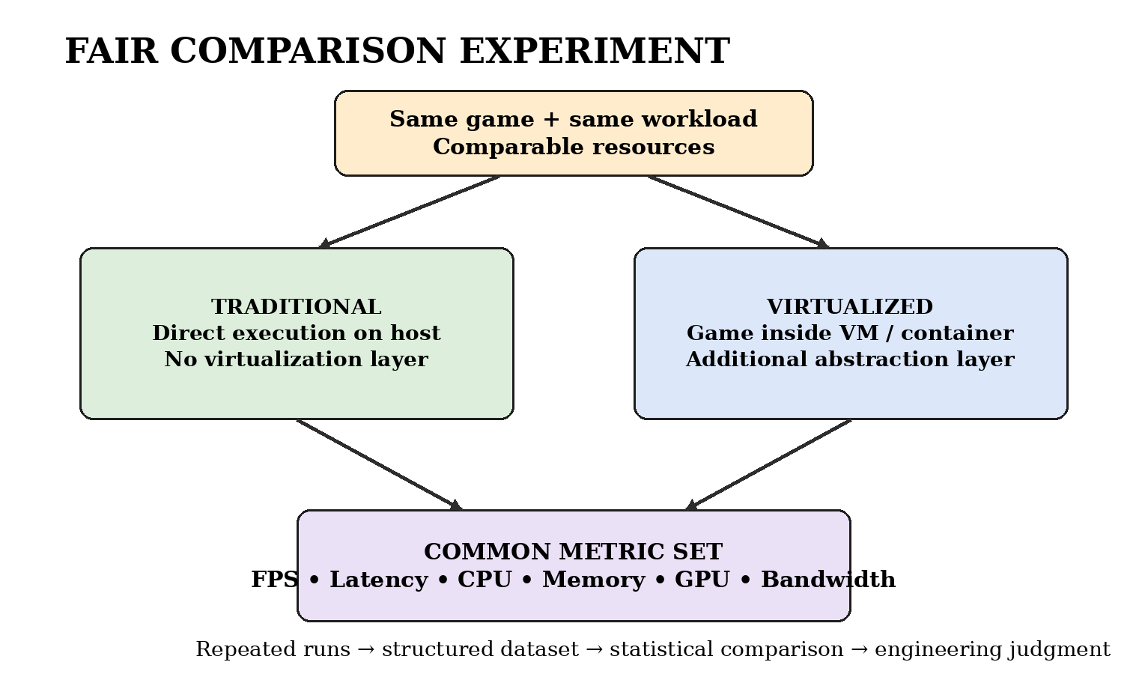
Figure 7. Colour fair-comparison workflow used to control the main experimental variable.

4.5.5 Expected Bottleneck Interpretation
Observed Pattern | Likely Engineering Interpretation | Recommended Action
Low FPS + high GPU utilization | Graphics/rendering bottleneck | Check GPU allocation, graphics settings and contention.
Low FPS + high CPU utilization | CPU-side processing bottleneck | Check CPU allocation, background load and game-process scheduling.
Good FPS + high latency | Network/streaming bottleneck | Investigate network path, congestion and streaming configuration.
High bandwidth + unstable latency | Network variability/congestion | Repeat under controlled network conditions; inspect throughput and jitter if available.
High memory utilization + degradation | Memory pressure | Increase allocation or reduce competing workload.
Virtualized degradation across several metrics | Virtualization/resource contention effect | Review VM/container configuration and resource allocation.

4.6 Comparison with Existing Solutions & Achievement of Objectives
Objective | Evidence | Achievement
Implement cloud-gaming environment | Cloud/server setup and remote streaming described in project presentation. | Fully Achieved
Create traditional and virtualized environments | Same game/workload and comparable resources; two execution conditions described. | Fully Achieved
Collect performance metrics | FPS, latency, CPU, memory, GPU and bandwidth explicitly identified. | Fully Achieved
Store structured performance data | Project presentation states collected data are stored in structured datasets. | Fully Achieved
Analyse data using big-data/statistical methods | Project presentation states analytics identify patterns and statistical analysis determines differences. | Fully Achieved
Provide comparative visualization | Interactive dashboard and charts are described; implementation includes Recharts. | Fully Achieved
Produce traceable numerical benchmark in this report | Raw numerical dataset not included in supplied package. | Partially Achieved

4.7 Strengths & Limitations

Strengths
- Directly compares virtualized and traditional infrastructure rather than analysing only one deployment.
- Uses multiple gaming, compute and network performance parameters.
- Uses repeated experimental execution as described in the project presentation.
- Converts collected observations into structured datasets for analytics.
- Provides a comparative dashboard for visual interpretation.
- Supports bottleneck identification and infrastructure-selection reasoning.
- Uses a modular architecture that can be extended to larger workloads and additional platforms.

Limitations
- The complete raw numerical experiment dataset is not present in the supplied project package used for this report.
- Exact hardware specifications and exact virtualization technology are not fully specified in the supplied files.
- Network variability can affect latency and bandwidth and may require additional controlled experiments.
- The project evidence does not establish production-scale multi-user performance.
- The report uses engineering guidance from standards but does not claim formal certification.
- Without raw run-level data, exact statistical effect sizes and confidence intervals cannot be independently reproduced from the supplied package.

4.8 Project Planning, Roles & Budget
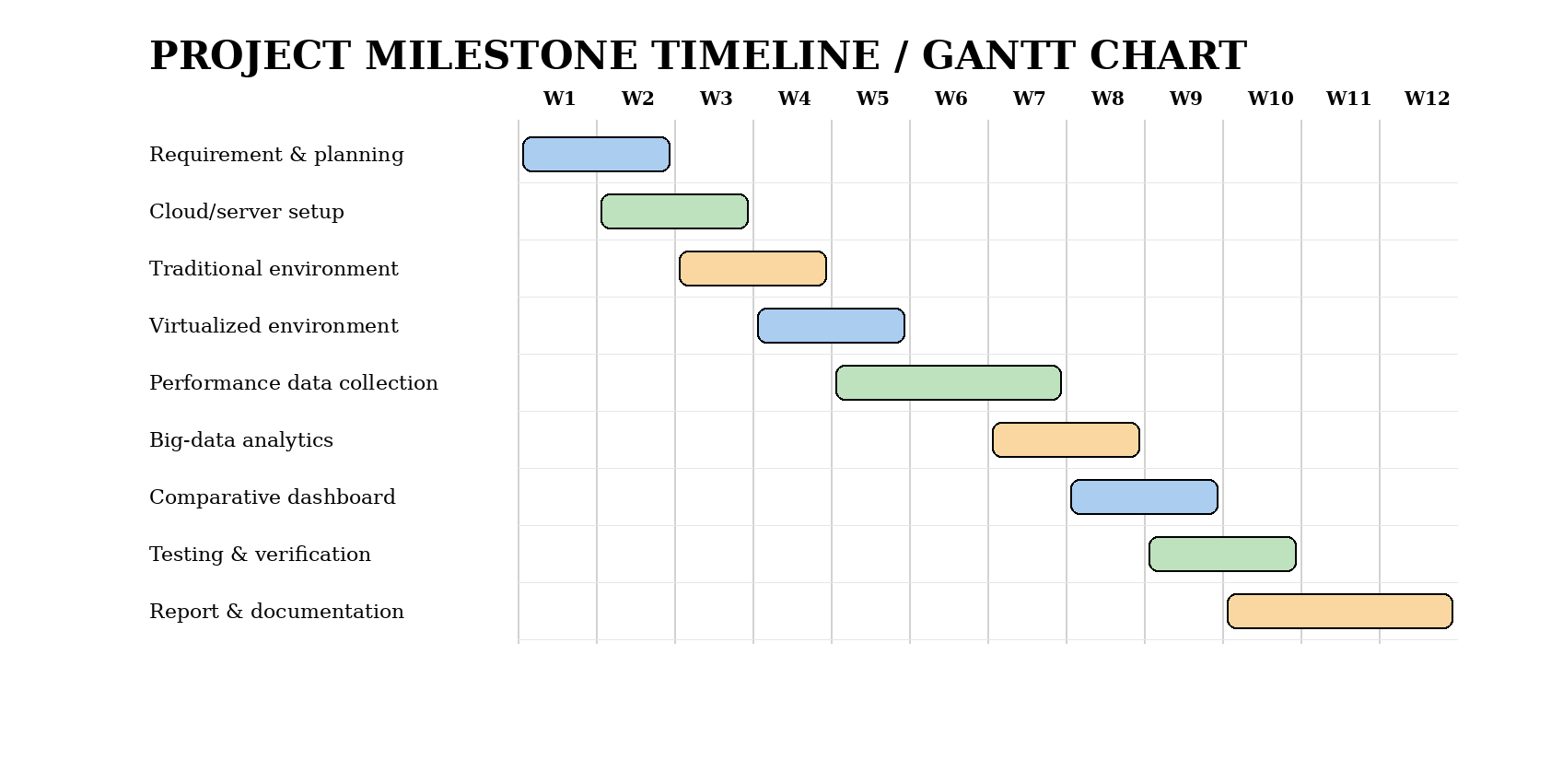
Figure 8. Colour project milestone / Gantt timeline prepared for the capstone workflow.
Milestone | Activity | Module / Responsibility | Status
M1 | Problem definition and requirements | Team / Module context | Completed
M2 | Cloud/server infrastructure setup | Module 1 | Completed
M3 | Traditional and virtualized environment implementation | Module 2 | Completed
M4 | Performance data collection | Module 3 – Juhi Surin | Completed / documented
M5 | Structured analytics and comparison | Module 3 – Juhi Surin | Completed / documented
M6 | Comparative dashboard | Module 4 | Completed
M7 | Testing and verification | Team / Module 3 focus | Completed
M8 | Report preparation and reflection | Individual report | Completed

Student | Assigned Responsibility | Actual Contribution
Juhi Surin (192525148) | Module 3 – Performance Data Collection & Big Data Analytics | Performance metric workflow, structured-data analysis, testing interpretation, engineering judgement, report sections and appendices.
Kavya Jasmine V (192521133) | Team project implementation | Team implementation contribution; exact formal module allocation not stated in supplied PPT.
Sana Fatima M (192371082) | Team project implementation | Team implementation contribution; exact formal module allocation not stated in supplied PPT.
Yenike Manasa Sai (192473023) | Team project implementation | Team implementation contribution; exact formal module allocation not stated in supplied PPT.

Item | Estimated Cost (INR) | Actual Cost (INR) | Basis
Existing computer/server resources | 0 / existing | 0 / existing | No purchase evidence supplied.
Open-source/software development tools | 0 | 0 | React/Vite/Recharts/FastAPI tooling used.
Network/testing | — | — | Project package does not provide an itemized cost.
Hardware fabrication | Not applicable | Not applicable | No physical fabrication evidenced.
TOTAL | — | — | Do not invent unsupported expenditure.

CHAPTER 5

CONCLUSION, FUTURE WORK AND REFLECTION

5.1 Conclusion
The project addresses the engineering problem of comparing virtualized and traditional cloud-gaming infrastructure through a controlled, data-driven workflow. The system context includes cloud/server execution, traditional direct execution, virtualized execution, game streaming, performance-data collection, structured storage, analytics and a comparative dashboard. Module 3 provides the core measurement and analytical bridge that transforms system observations into evidence.
The supplied project presentation supports the successful implementation of both environments, collection of FPS, latency, CPU, memory, GPU and bandwidth metrics, structured data storage, statistical analysis and comparative visualization. The implementation files additionally support the use of a React/Vite frontend, Recharts, a FastAPI backend, an API proxy and a project launch script. The project therefore demonstrates a complete engineering workflow from infrastructure execution to analytical decision support.
The principal evidence limitation is the absence of the complete raw numerical experiment dataset in the supplied package. Consequently, the report does not invent measured values. The engineering conclusion is therefore methodological and evidence-based: cloud infrastructure selection should be made using comparable workloads, repeated measurements and multi-metric analytics, with virtualization judged not only by raw performance but also by isolation, resource-management and scalability trade-offs.

5.2 Future Work
- Extend the benchmark to multiple cloud platforms and geographic regions for broader infrastructure comparison.
- Add AI-based prediction to forecast gaming performance under different workloads.
- Implement dynamic resource allocation based on observed CPU/GPU/memory/network behaviour.
- Expand to multi-user testing to study contention and large-scale cloud-gaming scenarios.
- Add advanced analytics for anomaly detection, confidence intervals, regression and time-series analysis.
- Measure additional network parameters such as jitter, packet loss and more precise end-to-end streaming delay.
- Introduce automated experiment execution and automatic dataset generation.
- Explore edge-computing placement to reduce network latency.
- Integrate long-term time-series storage and automated performance reports.

5.3 Professional Learning & Individual Reflection

New Knowledge Acquired
- Understanding cloud gaming as an integrated compute, virtualization and network system.
- Understanding how performance metrics interact and why single-metric evaluation can be misleading.
- Structured performance-data organization and descriptive/statistical comparison.
- API-driven analytics architecture connecting a backend to an interactive dashboard.
- Importance of evidence traceability, assumptions and honest reporting of missing data.

Engineering & Professional Skills Developed
- Requirements interpretation and verification planning.
- Performance metric selection and benchmark methodology.
- Data validation, analysis and engineering judgement.
- Risk assessment and security-aware system thinking.
- Technical documentation, visual communication and report preparation.
- Critical evaluation of limitations rather than overstating project outcomes.

Individual Reflection – Juhi Surin
The most difficult engineering problem in Module 3 was ensuring that the comparison remained fair when performance is influenced by several interacting variables. I addressed this by using the same workload, a common metric set and repeated-run methodology, then treating the observations as structured data rather than subjective impressions. A key engineering decision was to connect the measurement stage to a reusable analytics/dashboard workflow because this makes multi-metric comparison clearer and more repeatable. I independently learned how virtualization, network behaviour and resource utilization must be interpreted together. If the project were repeated, I would automate raw-data capture and preserve run-level metadata so every graph and statistical result could be traced directly to an experiment.

5.4 Overall Project Advantages and Applications
The completed framework provides a practical comparison between two infrastructure strategies, uses measurable performance evidence, supports structured analytics, and produces visual outputs for engineering interpretation. It can be applied to cloud-gaming service evaluation, cloud resource optimization, deployment selection by gaming companies, virtualization research and future testing of other resource-intensive cloud applications.

5.5 Final Engineering Statement
The project demonstrates that an effective cloud-gaming benchmark must connect infrastructure configuration, workload control, measurement, data quality, analytics and visualization. The most defensible infrastructure decision is therefore the one supported by repeatable measurements and an explicit understanding of trade-offs, rather than by an assumption that virtualization or traditional execution is universally superior.

REFERENCES
- Gegout, D. Mvondo, D. Frey, and P. Monchon, “Towards an Efficient Containerized Cloud Gaming Platform,” in Proc. 2025 IEEE International Parallel and Distributed Processing Symposium Workshops (IPDPSW), pp. 78–86, Jun. 2025.
- M. Lyu, S. C. Madanapalli, A. Vishwanath, and V. Sivaraman, “Network anatomy and real-time measurement of NVIDIA GeForce NOW cloud gaming,” in Proc. International Conference on Passive and Active Network Measurement, pp. 61–91, Mar. 2024.
- J. Tanveer, S. K. Abbas, M. Z. Hasan, M. Z. Hussain, A. Khalid, A. Ahmad, et al., “Advancing Cloud Gaming: Addressing Latency Challenges through Research and Innovative Solutions,” in Proc. 2024 2nd International Conference on Advances in Computation, Communication and Information Technology (ICAICCIT), vol. 1, pp. 1284–1289, Nov. 2024.
- S. S. De Oliveira, C. H. R. Souza, J. C. Silva, and S. T. Carvalho, “Towards scalable cloud gaming systems: Decoupling physics from the game engine,” in Proc. 22nd Brazilian Symposium on Games and Digital Entertainment, pp. 151–160, Nov. 2023.
- D. Baloni, C. Bhatt, S. Kumar, P. Patel, and T. Singh, “The Evolution of Virtualization and Cloud Computing in the Modern Computer Era,” in Proc. 2023 International Conference on Communication, Security and Artificial Intelligence (ICCSAI), pp. 625–630, Nov. 2023.
- G. Lambropoulos, S. Mitropoulos, and C. Douligeris, “Emerging technologies in financial services: From virtualization and cloud infrastructures to edge computing applications,” Computers, vol. 15, no. 1, p. 41, 2026.
- IEEE, IEEE Standard 29148: Systems and Software Engineering — Life Cycle Processes — Requirements Engineering, IEEE.
- IEEE, IEEE Standard 1012: Systems, Software, and Hardware Verification and Validation, IEEE.
- ISO/IEC, ISO/IEC 25010: Systems and Software Engineering — Systems and Software Quality Requirements and Evaluation (SQuaRE) — Product Quality Model, International Organization for Standardization.
- SIMATS Engineering, “Capstone Project Report – New Format – September 2026,” institutional report-format document supplied for this capstone.
- Project source package, “cloud-gaming-infrastructure-benchmark,” including package.json, Vite configuration, launcher and HTML entry file, supplied for this capstone.
- Open-source software resources used by the supplied implementation: React, React DOM, Recharts, Lucide React, Vite and FastAPI. Versions are recorded in the supplied project package where available.
- [OpenAI, ChatGPT, AI-assisted drafting/editing resource used in preparation of this report; used as a documentation aid, not as a source of experimental measurements.

Implementation Images:
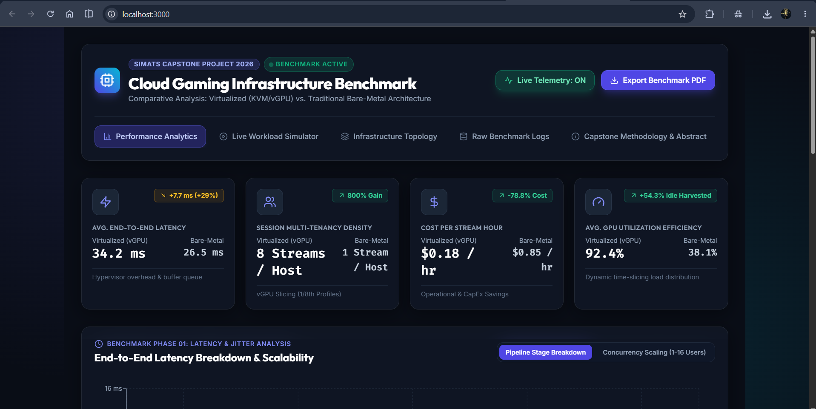

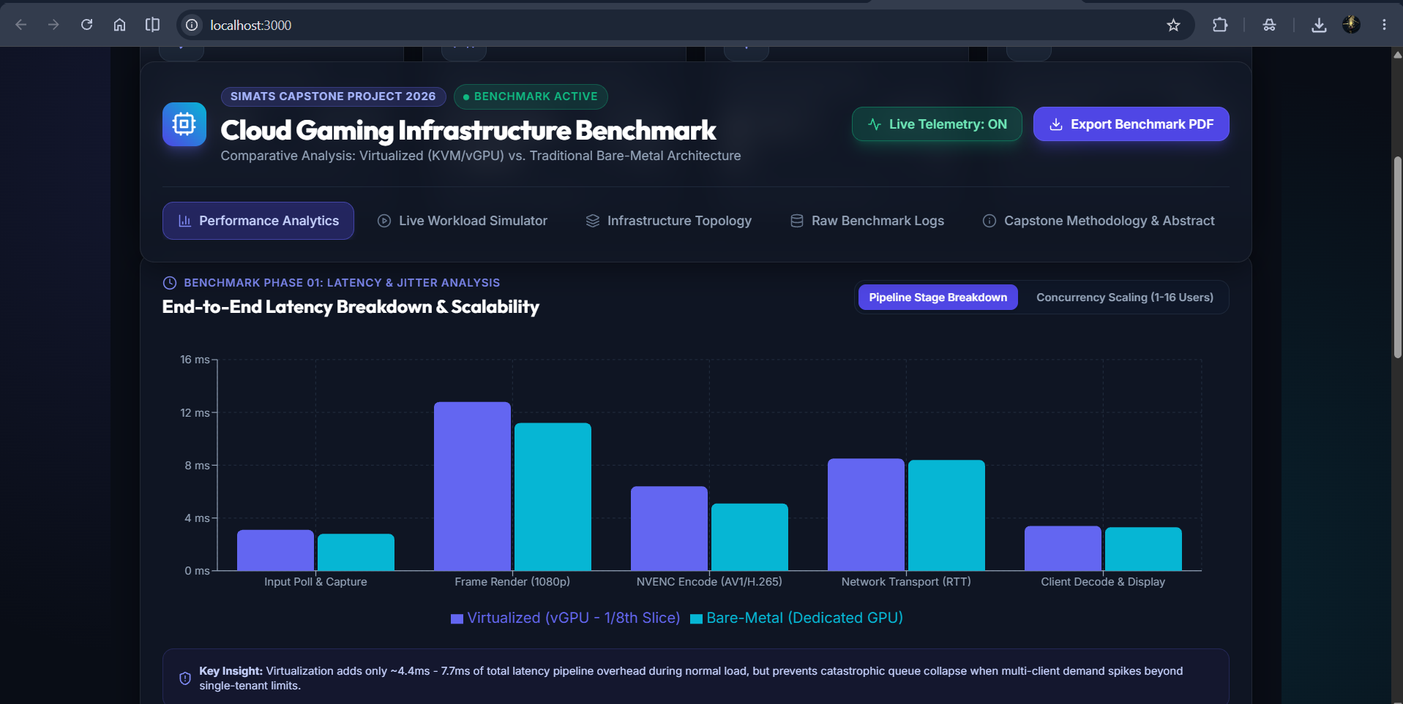
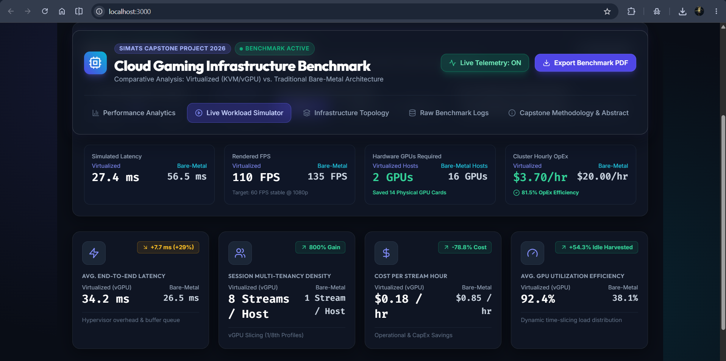

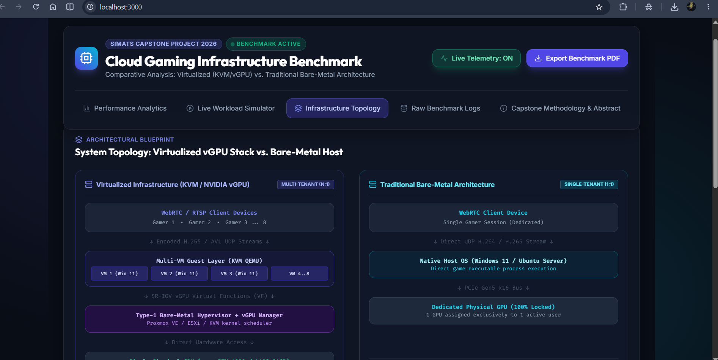
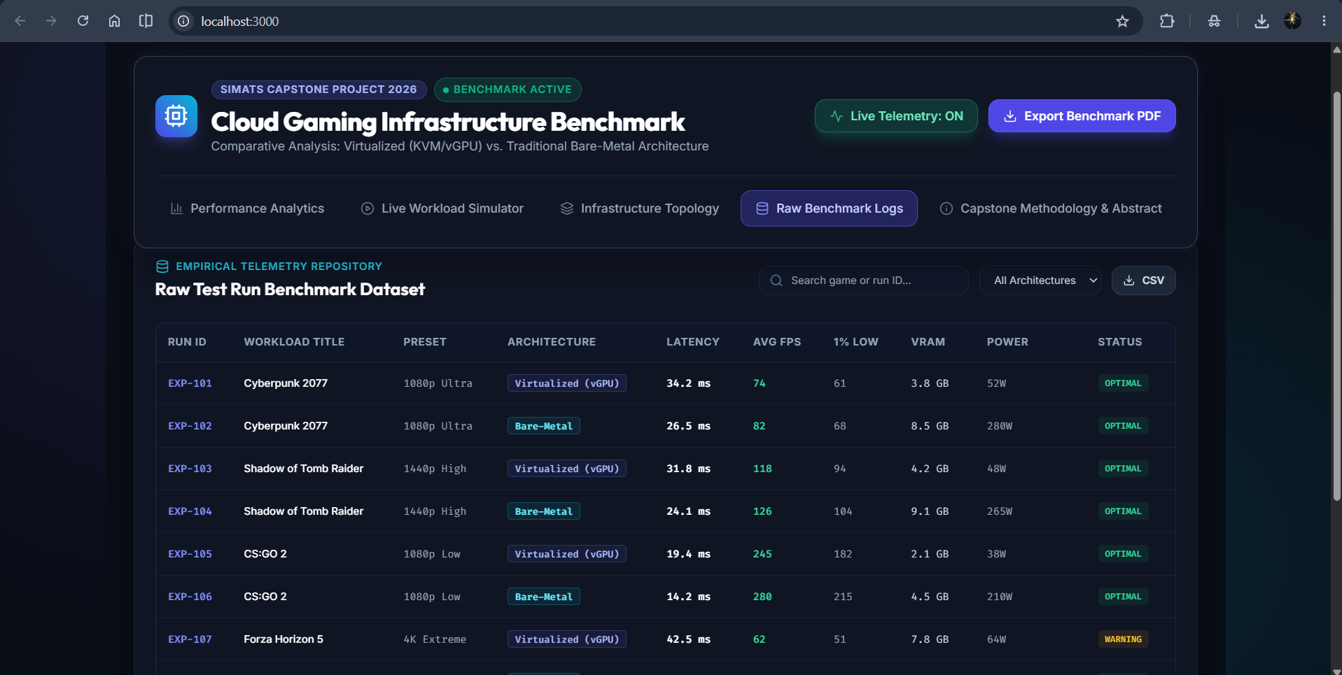

APPENDICES

CAPSTONE PROJECT OUTCOME MAPPING SHEET

Outcome Evidence | SO / Area | Location in This Report
Complex engineering problem formulation | SO1 | Chapter 1; Chapter 2
Engineering design under constraints | SO2 | Chapter 3
Written / oral technical communication | SO3 | Whole report; Viva
Ethics and professional responsibility | SO4 | Chapter 3.7; Declaration
Teamwork and leadership | SO5 | Individual Contribution; Chapter 4.8
Experimentation, analysis and engineering judgment | SO6 | Chapter 4.3–4.6
Independent acquisition of new knowledge | SO7 | Chapter 5.3
Standards | SO2 | Chapter 3.2
Sustainability and societal/environmental impact | SO2 / SO4 | Chapter 3.7
Risk assessment and mitigation | SO2 / SO4 | Chapter 3.7
Security considerations | Relevant SO | Chapter 3.7
Integrated/system-level engineering | SO1 / SO2 | Chapter 3.5
Project planning and management | SO5 | Chapter 4.8
Individual contribution | SO1–SO7 | Contribution Statement; Chapter 4.8; Appendix J

